Thanksgiving Desserts Ideas and shopping List

Apple Pie
2 pie crusts (top & bottom)
Flour
Shortening
Salt
Butter
6-7 c granny smith apples
sugar
nutmeg
cinnamon
butter
salt
flour
egg

Apple Crisp
6-7 cups granny smith apples
sugar
nutmeg
cinnamon
cloves
butter
flour
brown sugar

Caramel Sauce
Sugar
Brown sugar
Corn syrup
Evaporated milk
Pt. heavy whipping cream
Butter & vanilla

Oreo Cream Pie
Oreos
Butter
Egg yolks
Cornstarch
Whole milk
Unsweetened chocolate
Semi-sweet chocolate
Vanilla
Whipped cream

Junior’s Cheesecake
Bittersweet or semi-sweet chocolate (10 oz)
Butter
Flour
Eggs (6)
Salt
Sugar
cream cheese (3 sticks)
cornstarch
vanilla
whipping cream

Hot Fudge Sauce
Chocolate chips
Sugar
Evaporated milk
Butter
vanilla

Pumpkin Pie
Buy from Costco?
Pie crust
Flour
Shortening/butter
Salt
Sugar
Eggs
Pumpkin puree
Pumpkin pie spice, or cinnamon, ginger, cloves,
evaporated milk.

Whipped Cream
From a can or
heavy cream to whip.

Berry Pie
Buy Marie Calendar’s

Sugar Cookie Place cards
Butter
Sugar
Eggs
Vanilla extract
Lemon extract
Almond extract
Flour
Baking soda
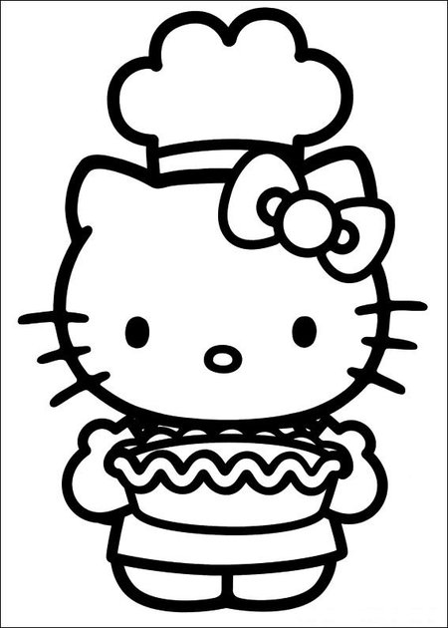
Salt
Meringue powder
Powdered sugar
Food dye

Other Desserts to try
___________________
___________________
___________________
___________________
___________________
___________________

