Thanksgiving Grocery Shopping

Turkey:
1 lb. per person
carrot
onion
celery
orange
chicken stock
herbs; thyme,
bay leaf,
rosemary
chicken broth,
apple cider
Butter
Thermometer
Other ___________
Other ___________
Other ___________

Giblet Gravy:
Giblets
Butter
Olive Oil
Onion
Celery
Carrots
Garlic
Flour
White wine
Chicken broth
Thyme
Pepper
Other ____________
Other ____________

Mashed Potatoes:
Russet Potatoes – 6 oz. per per person
Heavy Cream
Butter
Sea salt
Other ______________
Other ______________

Sweet Potato or Yam Casserole recipes
Brown sugar
sugar
Spices, ginger, nutmeg, cinnamon, allspice, cloves
Butter
cream
Egg
Marshmallow
Flour
pecans
Other _________________
Other _________________

Stuffing:
Bread or homemade rolls
Butter
Onion
Celery
Ground Sage
Other ________________

Cranberry Sauce
1 bag fresh cranberries
sugar
orange zest
cinnamon, mint leaves
sugar
apple juice
Other _________________

Rolls
Bread flour
Sugar
Non-fat dry milk
Yeast
Eggs
Shortening or butter
Other ____________________

Green Bean Casserole
2 cans green beans
1 can cream of mushroom soup
milk
French fried onions

Pretzel Jello Salad
Pretzels
brown sugar
strawberry jello
cream cheese
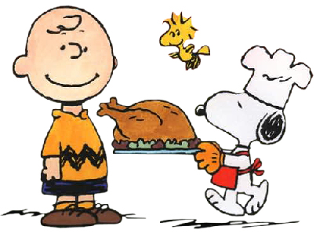
cool whip
butter

Canned corn

Beverages

